**Exercise: Calculator using Javascript and ExpressJS**

This document defines a complete walkthrough of creating a **Calculator** application with the [Express.js](http://expressjs.com/) Framework, from setting up the framework, to implementing the models, views and controllers necessary for our application to function.

You can download the **calculator’s skeleton** from [here](http://svn.softuni.org/admin/svn/soft-tech/Jan-2019/JavaScript/10.Basic-Web/Exercise/05.%20JavaScript-ExpressJS-Overview-Exercise-Calculator-Skeleton.zip). The rest of the needed non-optional software is described in the guide above.

**Base Project Overview**

Node.js is a **platform** written in **JavaScript** and provides **back-end** functionality. Express is a **module** (for now we can associate module as a **class** which provides some functionality), which wraps Node.js in way that makes coding faster and easier and it is suitable for the **MVC** architecture.

Initially the project comes with the following structure:

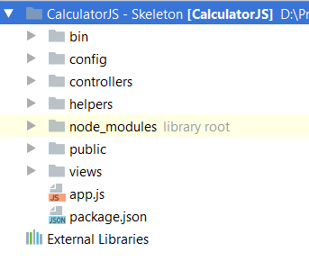

We can see several folders here. Let look at them one by one and see what are they for:

**bin –** Contains a single file named **www**, which is the **starting point** of our program. The file itself contains some **configuration** logic needed to run the server **locally**.

**node_modules** (library root) – As far as the name tells us, in this folder we put every library (**module**) that our project depends on.

**public** – Everything in our **public** folder (**files**, **images**, etc.) will be **accessible** by **every user**. We’ll cover on that later.

**routes** –Afolder in which we will put our **route** configurations. We’ll find out what a **route** is in a bit.

**views –**There, we will store the views for our model. Again, we will use templates with the help of the **Handlebars** view engine.

**app.js** – The script containing the logic needed to **start the server**.

**package.json** – a file containing project information (like the project's **name**, **license** etc.). The most important thing is that there is a "**dependencies**" part, where all the names and versions of every module that our projects uses will reside.

Let’s see what we have in the skeleton before we start working on it:

**Open the Project**

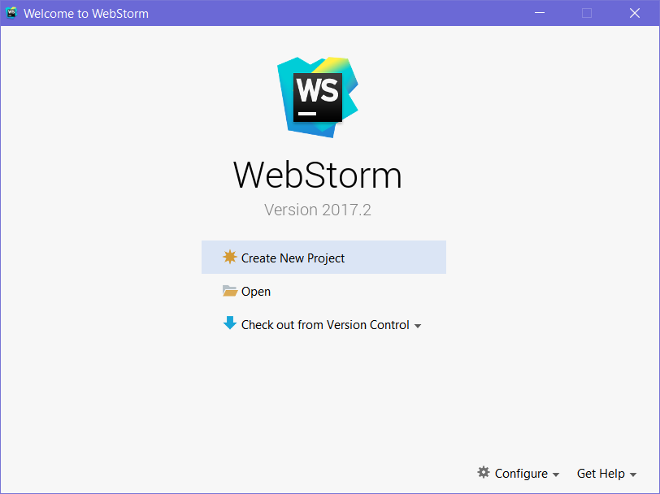

Let’s go ahead and load the skeleton. Click "**Open**", and find the downloaded and unzipped skeleton project:

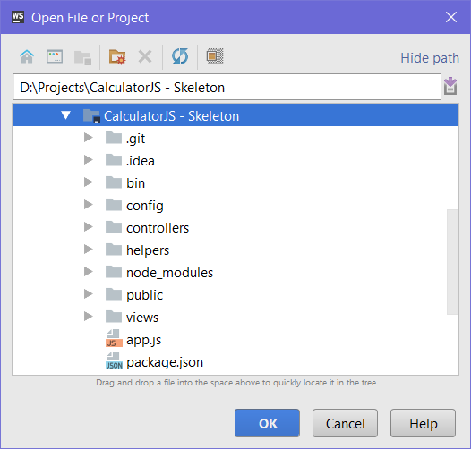

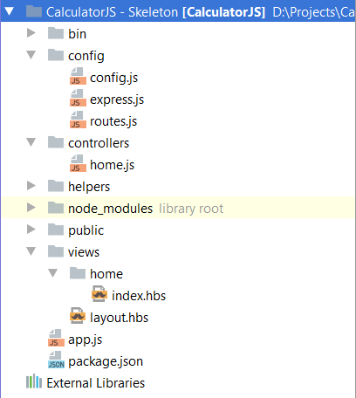

This is our Node.js project. In the previous steps, we described on how we got here. Now let’s talk about **Node.JS**:

As we know, it's a **platform** written in **Javascript**, providing **back-end** functionality. This gives us a lot of flexibility, because our **front-end** usually uses **JavaScript** as well. This makes mutual **communication** easier.

Furthermore, Node.JS is fast because it uses C++ behind the scenes and also because it’s capable of making asynchronous calls. It uses the [event loop system](https://www.tutorialspoint.com/nodejs/nodejs_event_loop.htm).

Summary: we have downloaded the project and we are ready to start writing code!

**Run the Project**

Now that we’ve opened the project, let’s try running it, so we can see what we’re working with. Go to the top right of WebStorm, where you’ll find a Run button, which looks like a green play button:

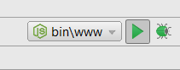

That’s how we’ll start our Express app. Go ahead and click the button. If everything goes according to plan, we should see this message on the console:

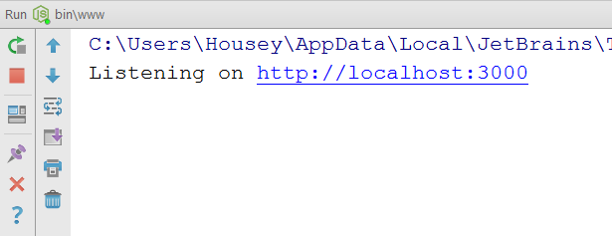

Now we can open the page and see what we have:

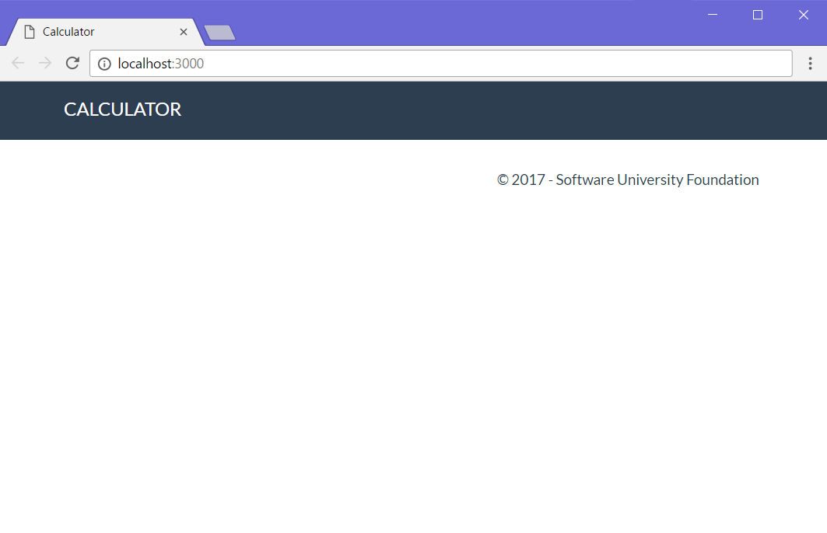  
It doesn't look like much, but at least we have the basic layout down! Let's get to work on implementing some functionality!

**Implementing Functionality**

1. **Create Calculator View**

Before we can have any functionality, it would be nice to have an idea of what we’re working against, so let’s go ahead and **create** a **form**, which the **user** will use for **calculations**:

Go into the **views/home** folder and open the **index.hbs** file:

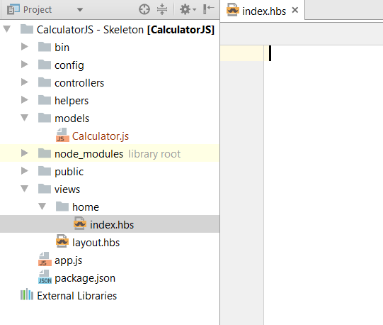

It’s empty?! How does the header and footer seen above get displayed then? The answer is, we use a **global** **layout** **file**, so we don’t have to copy-paste our page layout into every single view in our project (which could have **tens** or **hundreds** of views). All the **actual design HTML** is inside **layout.hbs**. We won’t be touching that, so let’s go to the **index.hbs** file and add our form:

|  |
| --- |
| <**div class="container body-content span=8 offset=2"**>  <**div class="well"**>  <**form class="form-inline" action="/" method="POST"**>  <**fieldset**>  <**div class="form-group"**>  <**div class="col-sm-1 "**>  <**input type="text" class="form-control" id="leftOperand" placeholder="Left Operand"  name="calculator[leftOperand]" value="**{{**calculator**.**leftOperand**}}**"**>  </**div**>  </**div**>   <**div class="form-group"**>  <**div class="col-sm-4 "**>  <**select class="form-control" name="calculator[operator]"**>  <**option value="+"**{{**selectif calculator**.**operator '+'**}}>+</**option**>  <**option value="-"**{{**selectif calculator**.**operator '-'**}}>-</**option**>  <**option value="*"**{{**selectif calculator**.**operator '*'**}}>*</**option**>  <**option value="/"**{{**selectif calculator**.**operator '/'**}}>/</**option**>  </**select**>  </**div**>  </**div**>   <**div class="form-group"**>  <**div class="col-sm-4 "**>  <**input type="text" class="form-control" id="rightOperand" placeholder="Right Operand"  name="calculator[rightOperand]" value="**{{**calculator**.**rightOperand**}}**"**>  </**div**>  </**div**>   <**div class="form-group"**>  <**div class="col-sm-2 "**>  <**p**>=</**p**>  </**div**>  </**div**>   <**div class="form-group"**>  <**div class="col-sm-4 "**>  <**input type="text" class="form-control" id="result" placeholder="Result"  name="result" value="**{{**result**}}**"**>  </**div**>  </**div**>   <**div class="form-group"**>  <**div class="col-sm-4 col-sm-offset-4"**>  <**button type="submit" class="btn btn-primary"**>Calculate</**button**>  </**div**>  </**div**>  </**fieldset**>  </**form**>  </**div**> </**div**> |

We will **save the state** of the operands and operator for ease of use, so the **handlebars syntax** you see here does just that. The **{{selectif}}** helper is a bit more special: it selects the operator from the dropdown list, **based on** the last used operator. We’ll see how that’s implemented a bit later. For now, let’s navigate to our web app at <http://localhost:3000> and see how we’re doing:

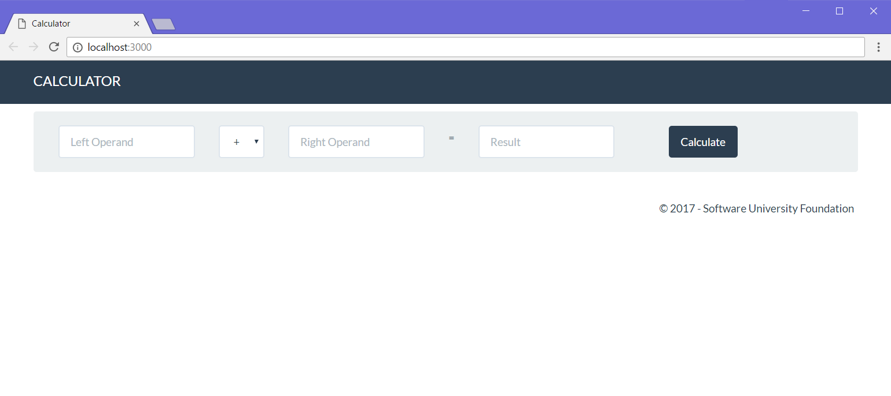

Looking good! Except it doesn’t do anything. First, let’s get down to making the thing, which will hold our data: the **model**.

**Create Calculator Model**

It’s time to design our main model – the **Calculator**. It will contain the following properties:

* **leftOperand**
* **operator**
* **rightOperand**

Let’s create our model in the **JavaScript** way. Since we’re **not** using a database in this exercise, we’re just going to define the calculator as a **simple JavaScript class**.

Create a folder, called "**models**" and inside it, create a **JavaScript** file, named "**Calculator.js**":

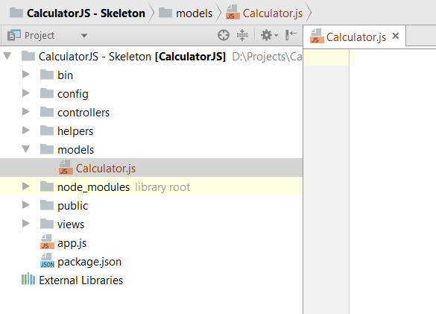

Now, let’s write the code, which will define our **Calculator** model:

1. Create a function, which will be called upon creating a new calculator instance:  
   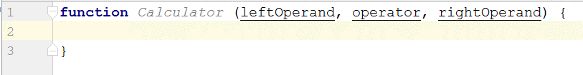

Inside it, **define** the calculator **properties**:

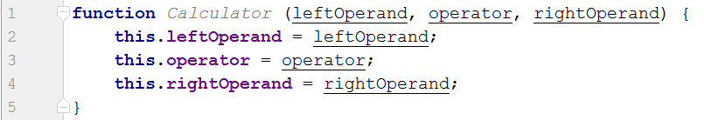

Create a **function** for **calculating** the result from the **properties**:  
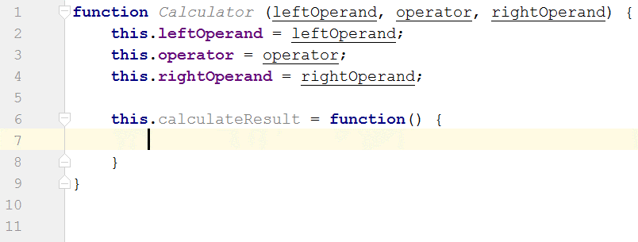  
Inside this function, we’ll write the logic, which is needed for calculating the result from the operands and operator. Let’s create the logic, needed for that:

Write the calculation logic:  
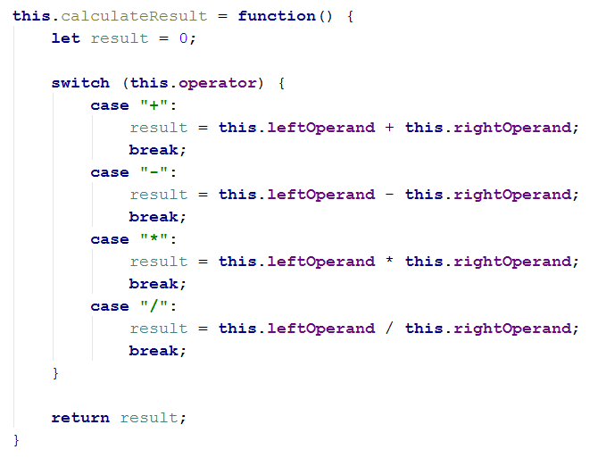

Almost done: **export** our model so it can be **visible** for the **outer world** (outside of the **Calculator.js** file):

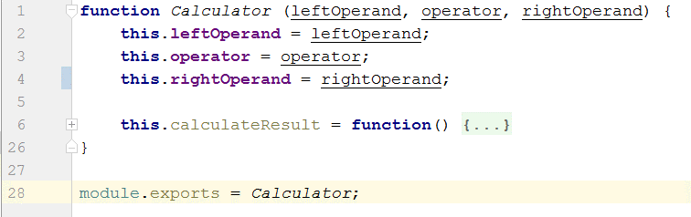

Summary: We now know how to create a simple model and make it visible to the outside world.

**Add a Route, which Calls the Controller Action**

As for the routing – with **ExpressJS**, all our routing logic is usually located within a file, called **routes.js**. Here’s what that currently looks like:

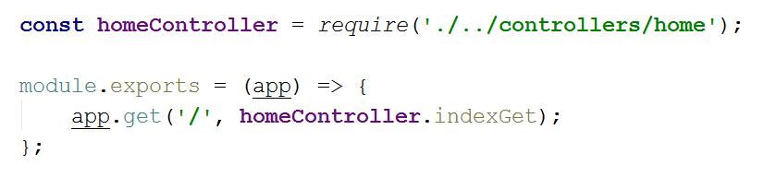

Let’s break this code down into understandable chunks:

* **const homeController = require('./../controllers/home')**

This bit of code **imports** our controller’s logic. Before we can **call** any methods, we need to know those methods **exist**, right?

* **module.exports**

This is the piece of code which takes the code inside it and **exposes** it to the outside world. We’re putting our code here, because Node.JS needs to have **access** to it, so it can **execute the action** when our user **calls** the specified **route** (examples: **/calculate**, **/edit/2**, **/login**).

* **app.get('/', homeController.indexGet)**

This piece of code tells Node.JS to **listen** for any **GET requests** on the "**/"** route, and when it finds one – to execute the **homeController.indexGet** method (this is why we needed to **import** the **home controller** up there using **require()**.

Now that we've understood how the **routing system** in **Express.JS** works, it's time to **add** our **own route**, which calls our own **controller** **action**, which gets the data from the user and uses it to calculate the result.

Since we’re going to be sending out **form data** to the server, we’re going to be using a **HTTP** **POST** **request** to do it. Hence, we need to tell **routes.js** to expect **POST requests** and **execute** the appropriate controller action:

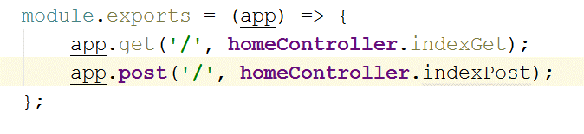

We just made a **route**, which listens on "**/**", and upon matched, executes the **indexPost** action inside the **home controller**. That’s alright, but the problem is we **don’t have** an action with that name yet. So, guess what happens if we try to send a form to the server:

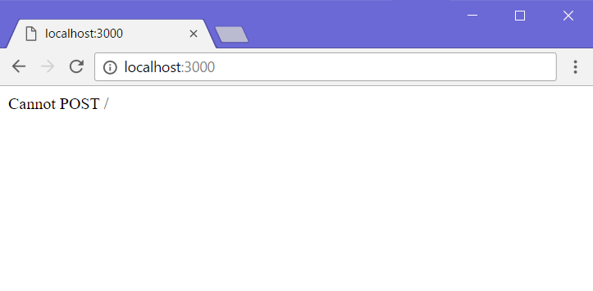

Not so great. For our final trick, we'll create our own controller action, which will **process** what the user sent us and **return** a **view** with the **result** from the calculation.

**Implement the Controller Action**

Now that we’ve created the **view**, which will **hold our data** and allow the **user** to **interact** with our web application, it’s time to create the driving force behind the whole app – **the controller**.

As it turns out, we already have a **home controller** set up, and an action, set up on the "**/**" route, otherwise we wouldn't even be able to see our calculator. You can find the **home controller** in the "**controllers**" folder. Let's see what it looks like:

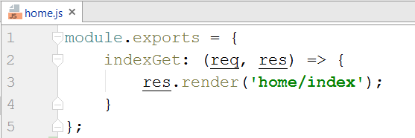

Not much going on here… Let’s break it down:

* **module.exports** 🡺 the piece of code, which takes the code inside it and **exposes** it to the outside world. We’re putting our code here, because the **router** needs to have **access** to it, so it can **execute the action** when our user **calls** the specified **route** (right now, that’s "**/**").
* **indexGet: (req, res)** 🡺 This is the actual **controller action**. It’s a function, which **holds the** **logic**, which will be **executed**, when it's **called**. It’s **no different** than a **regular method**.   
  It has 2 parameters: **req** and **res**. They hold data about the **HTTP** **request** and **HTTP** **response** respectively. They'll be used for **getting data** from the user and also doing things such as **rendering views** in the **response**. Remember – all we’re doing here is returning different **HTML code**, based on the logic we've implemented in our app.
* **res.render('home/index')** 🡺 This function **renders** a **view** in the **response** (in essence, takes whatever’s inside of "**home/index.hbs**", runs it through the **Handlebars** templating engine, and returns it back to the user.

So, using this newfound knowledge, let’s try to create our own **action**.

First, we’ll start off by declaring the action:

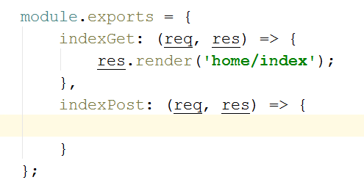

As we know from above, we have **req** and **res** parameters. We’ll use the **req** parameter to get the data from the **request**. That’s the data the user **sent us** through the **form**. We can get a hold of that data by accessing **req.body**:

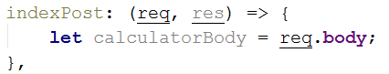

Before we continue, let’s see what that property would hold if we looked at it during a **debug session**:

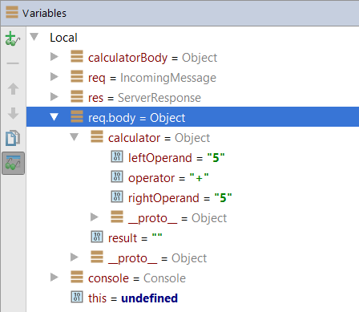

The data comes through the request as a **calculator** variable. Why does that happen? Well, let's look at what data we’re sending the server with a tool like **Chrome Developer Tools** **(F12)**:

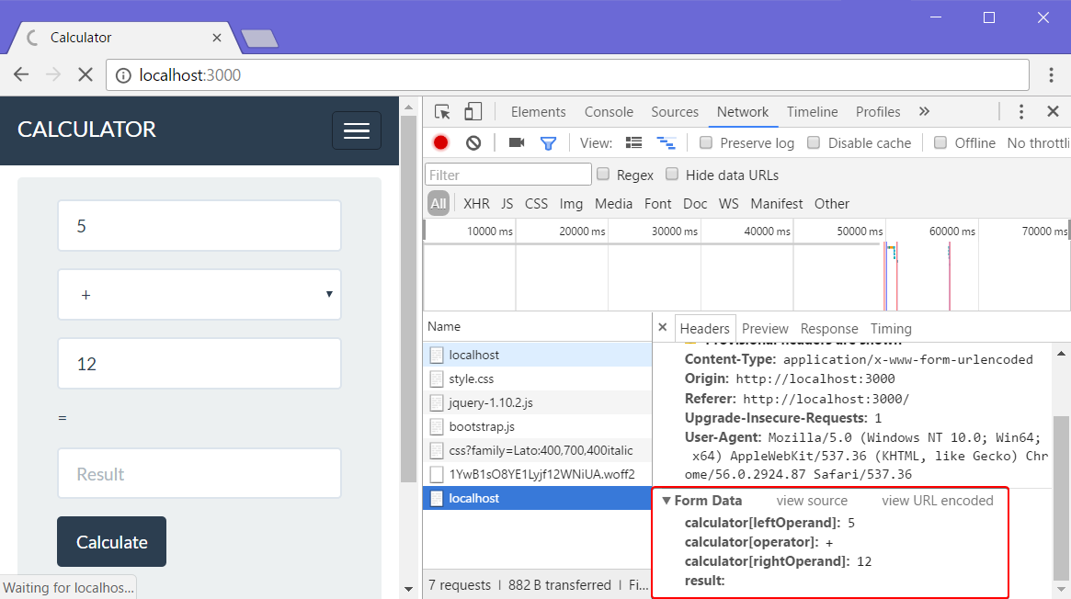

The form has a **calculator variable** with **3 values**, sent as **strings**. And as such, that comprises the **request body** – something we can access by using the **req.body** property. Let's go back into our controller action and **process** the data.

We can access the properties of the calculator by accessing the **request** **body** and getting the **calculator** as a key:

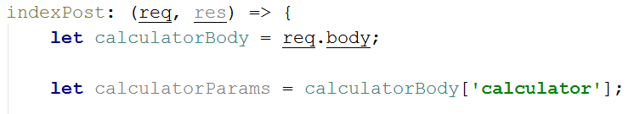

Accessing **calculatoryBody**'s values by the "**calculator**" key is the same as just writing "**req.body['calculator']**", but we’re extracting every step into variables for clarity.

Before we can use our **calculator model**, we need to tell the controller that it exists. We'll do that by **importing** it, using **require()** at the **top** of the file:



Next, we need to create an **instance** of our calculator model, which we’ll use for storing the data inside:

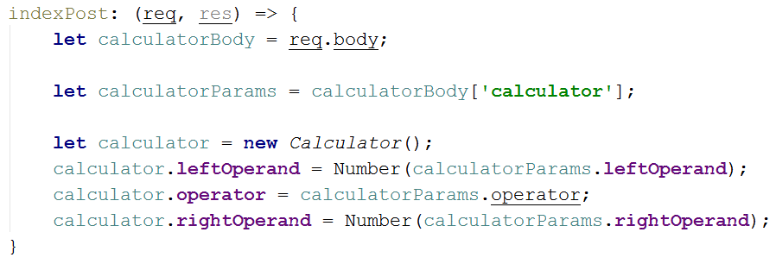

We use the **Number()** function to convert the operands from **strings** to **numbers**. Now that we've gotten the data, it's time to calculate the result from what we currently have. Remember that **calculateResult()** function we wrote a while ago? Now's the time to use it:

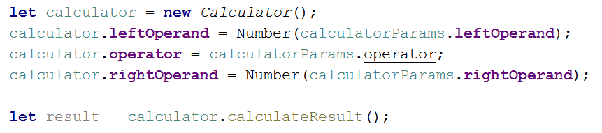

After that, all we have left is to **render** **the view**. We can do that by using the **render** function inside the **res** (response) method parameter:

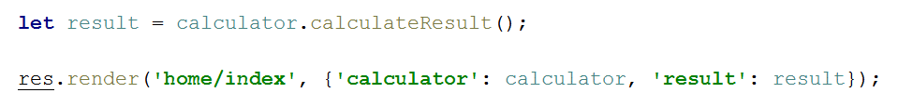

Let’s break down what **res.render()** does:

* **'home/index'**This parameter specifies which view to return.
* **{'calculator': calculator, 'result': result}**This parameter is a **JavaScript Object**, which specifies what we're going to **send** to **the view** (in our well-known **key** **->** **value** pairs).  
  So, when we send over the **calculator object** and the **result value** to the view, we can **fill** the **form fields** with our data. This happens here:  
  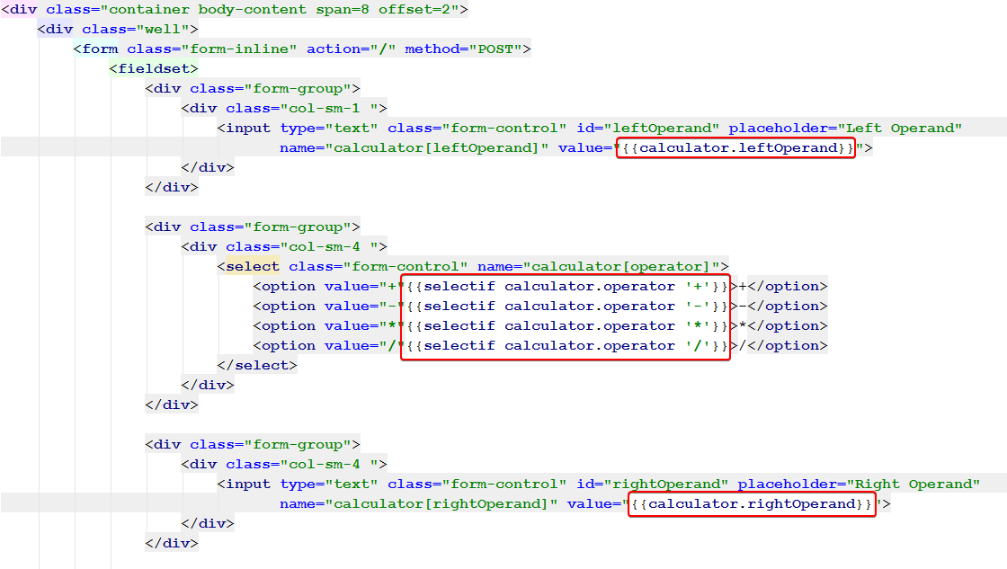

We use the data from the controller in the **home/index.hbs** view to set the **values** of the form inputs to whatever we want. In this case, we set the **operands**, and select the last used **operator**.

**Test the Application**

All our hard work should finally pay off now, right? If you’ve followed all the steps properly, and ***read all the explanatory text***, hopefully we should have a functioning calculator!

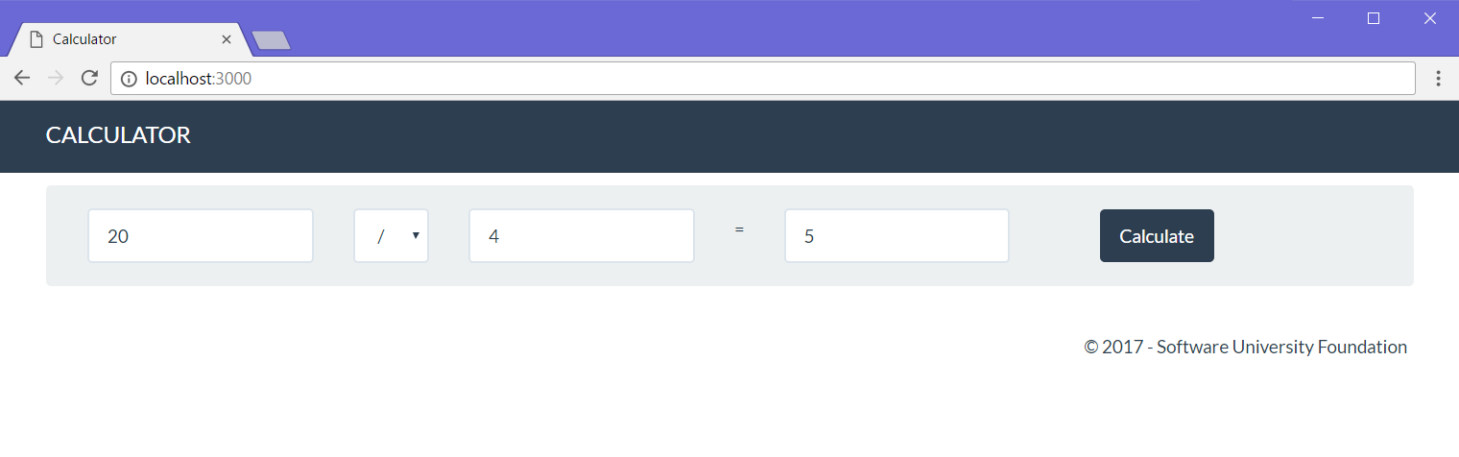

**\* Implement Extra Functionality**

Just like last time, you’re free to implement extra functionality like **extra operators**, **input validation**, and whatever else you can think of. Happy coding. ☺